**VISVESVARAYA TECHNOLOGICAL UNIVERSITY**

**“JnanaSangama”, Belgaum -590014, Karnataka.**



## LAB REPORT

**on**

OBJECT ORIENTED MODELING

***Submitted by***

**ROHIT RAMCHANDRA GANDHI**

**(1BM23CS417)**

***in partial fulfillment for the award of the degree of***

**BACHELOR OF ENGINEERING**

***in***

## COMPUTER SCIENCE AND ENGINEERING



**B.M.S. COLLEGE OF ENGINEERING**

**(Autonomous Institution under VTU)**

## BENGALURU-560019

**September-2024 to January-2025**

**B. M. S. College of Engineering,**

**Bull Temple Road, Bangalore 560019**

(Affiliated To Visvesvaraya Technological University, Belgaum)

**Department of Computer Science and Engineering**



**CERTIFICATE**

This is to certify that the Lab work entitled “**OBJECT ORIENTED MODELING**” was carried out by **ROHIT RAMCHANDRA GANDHI(1BM23CS417),** who is a bonafide student of **B. M. S. College of Engineering.** It is in partial fulfillment for the award of **Bachelor of Engineering in Computer Science and Engineering** of the Visvesvaraya Technological University, Belgaum during the year 2024-2025. The Lab report has been approved as it satisfies the academic requirements in respect of **Object-Oriented Modeling- (23CS5PCOOM)** work prescribed for the said degree.

**Syed Akram Dr. Jyothi S Nayak**

Assistant Professor Professor and Head

Department of CSE Department of CSE

BMSCE, Bengaluru BMSCE, Bengaluru

# Table of Content

|  |  |  |
| --- | --- | --- |
| **Sl.**  **No.** | **Experiment Title** | **Page No.** |
| **1** | **System Requirements Specification** | **4-18** |
| **2** | **Class Modeling** | **19-23** |
| **3** | **State Modeling** | **24-28** |
| **4** | **Interaction Modeling: Use Case Models** | **29-33** |
| **5** | **Interaction Modeling: Sequence Models** | **34-38** |
| **6** | **Interaction Modeling: Activity Models** | **39-43** |

**SOFTWARE REQUIREMENTS SPECIFICATION (SRS)**

1. **HOTEL MANAGEMENT SYSTEM:**

**1. Introduction**

**1.1 Purpose**

This document defines the software requirements for the Hotel Management System (HMS). It aims to provide a centralized solution to manage hotel operations efficiently, ensuring a seamless experience for both staff and guests.

**1.2 Scope**

The HMS is a comprehensive solution for managing reservations, check-ins, check-outs, billing, and customer relationship management. It caters to hotels of all sizes and integrates with third-party services like payment gateways and room service providers.

**1.3 Definitions, Acronyms, and Abbreviations**

* **HMS**: Hotel Management System
* **CRM**: Customer Relationship Management
* **API**: Application Programming Interface
* **POS**: Point of Sale

**1.4 References**

* IEEE Standard 830-1998 for SRS
* Hospitality Industry Guidelines

**1.5 Overview**

This document outlines the system's objectives, features, and operational requirements. Detailed descriptions are provided in subsequent sections.

**2. Overall Description**

**2.1 Product Perspective**

The HMS is a cloud-based platform with modular capabilities, supporting integrations with POS systems, booking portals, and payment gateways. It will replace manual processes with automated workflows, enhancing efficiency and accuracy.

**2.2 Product Functions**

* Reservation management, including online bookings.
* Front desk operations: check-ins, check-outs, and room assignments.
* Billing and invoicing with multi-currency support.
* Housekeeping and maintenance scheduling.
* Customer relationship management with loyalty programs.
* Inventory and vendor management.

**2.3 User Classes and Characteristics**

* **Hotel Managers**: Oversee operations and analyze reports.
* **Reception Staff**: Handle reservations and front desk operations.
* **Housekeeping Staff**: Receive and update task schedules.
* **Guests**: Interact with the system for booking and feedback.
* **IT Administrators**: Maintain and troubleshoot the system.

**2.4 Operating Environment**

* Hardware: Desktop computers, mobile devices, and POS systems.
* Software: Cloud-based platform accessed via web and mobile applications.
* Network: Secure internet connection.

**2.5 Design and Implementation Constraints**

* Adherence to data privacy laws (e.g., GDPR).
* Compatibility with legacy systems used in older establishments.
* Scalability to support chain hotels with multiple branches.

**2.6 Assumptions and Dependencies**

* Consistent internet access for cloud functionality.
* Compliance with third-party services' APIs.
* Availability of trained staff to operate the system.

**3. Specific Requirements**

**3.1 Functional Requirements**

1. The system shall allow users to book, modify, and cancel reservations.
2. The system shall enable front desk staff to manage check-ins and check-outs.
3. The system shall generate invoices and accept payments in multiple formats.
4. The system shall assign and track housekeeping tasks.
5. The system shall maintain customer profiles and loyalty points.
6. The system shall provide analytics and reporting dashboards for managers.

**3.2 Non-Functional Requirements**

1. **Performance**: The system shall process bookings in under 3 seconds.
2. **Reliability**: The system shall maintain 99.9% uptime.
3. **Security**: All guest data shall be encrypted.
4. **Scalability**: The system shall handle up to 10,000 concurrent users.
5. **Usability**: The system interface shall adhere to accessibility standards.

**3.3 Interface Requirements**

* **Hardware Interface**: Integration with POS and barcode scanners.
* **Software Interface**: APIs for booking platforms and payment gateways.
* **User Interface**: Responsive design for web and mobile applications.

**4. Appendices**

* Glossary of Terms
* Detailed System Architecture Diagram

**2)CREDIT CARD PROCESSING SYSTEM:**

**1. Introduction**

**1.1 Purpose**

This document defines the software requirements for the Credit Card Processing System (CCPS). The system is designed to facilitate secure, reliable, and efficient processing of credit card transactions for businesses and their customers. This document provides a comprehensive outline of the functional and non-functional requirements, design constraints, and system interfaces.

**1.2 Scope**

The CCPS is a centralized platform that enables businesses to process credit card payments securely and efficiently. The system supports functionalities such as transaction authorization, settlement, fraud detection, and reporting. It integrates with third-party payment gateways and complies with industry security standards such as PCI-DSS.

**1.3 Definitions, Acronyms, and Abbreviations**

* **CCPS**: Credit Card Processing System
* **PCI-DSS**: Payment Card Industry Data Security Standard
* **API**: Application Programming Interface
* **GUI**: Graphical User Interface

**1.4 References**

* IEEE Standard for Software Requirements Specifications (IEEE Std 830-1998)
* PCI-DSS Compliance Guidelines

**1.5 Overview**

This document is organized into sections that describe the overall system functionality, user characteristics, and specific requirements. Section 2 provides a high-level description of the system, and Section 3 details the system requirements.

**2. Overall Description**

**2.1 Product Perspective**

The CCPS is a modular application designed to handle end-to-end credit card transaction processing. It integrates with merchant systems, card networks, and banking infrastructure to ensure seamless payment workflows.

**2.2 Product Features**

Key features of the CCPS include:

* Real-time transaction authorization and processing
* Fraud detection and prevention
* Automated settlement and reconciliation
* Reporting and analytics dashboards
* Integration with third-party payment gateways

**2.3 User Characteristics**

The system is designed for the following user groups:

* **Merchants**: Use the system to process customer payments and view transaction reports.
* **Financial Institutions**: Handle transaction settlement and provide fraud detection insights.
* **System Administrators**: Manage and maintain system operations.
* **Customers**: Use the system indirectly through merchant transactions.

**2.4 Constraints**

* The system must comply with PCI-DSS and other financial regulations.
* It should ensure compatibility with existing merchant and bank hardware/software systems.
* High availability and fault tolerance are required to handle critical payment operations.

**2.5 Assumptions and Dependencies**

* A reliable internet connection is assumed for real-time processing.
* The system depends on third-party gateways and bank APIs for transaction completion.

**3. Specific Requirements**

**3.1 Functional Requirements**

* **Transaction Authorization**:
  + Validate credit card details and approve transactions in real time.
  + Notify merchants and customers of transaction status.
* **Fraud Detection**:
  + Identify suspicious activity using rule-based and AI-powered algorithms.
  + Generate alerts for flagged transactions.
* **Settlement and Reconciliation**:
  + Automate the process of transferring funds between parties.
  + Provide detailed transaction reports for auditing.
* **Reporting**:
  + Offer dashboards for transaction volume, revenue trends, and fraud analysis.
  + Support export of reports in standard formats (e.g., PDF, CSV).

**3.2 Performance Requirements**

* The system should support up to 1,000 concurrent transactions.
* Response time for transaction authorization must not exceed 3 seconds.
* Data backups must be performed every 15 minutes to minimize data loss.

**3.3 Interface Requirements**

* **GUI**:
  + User-friendly design for merchants and administrators.
  + Role-based dashboards with customizable views.
* **API Integration**:
  + RESTful APIs for integration with third-party gateways and banking systems.

**3.4 Design Constraints**

* The system must be developed using secure, scalable technologies.
* Hardware requirements should be minimal to ensure widespread adoption.

**3.5 Non-Functional Attributes**

* **Reliability**: 99.99% uptime to support critical financial operations.
* **Security**: Adherence to PCI-DSS standards, including encryption and tokenization.
* **Usability**: Simple and intuitive user interfaces for all stakeholders.
* **Scalability**: Capability to handle increasing transaction volumes.
* **Maintainability**: Modular architecture for ease of updates and debugging.

**3.6 Performance, Schedule, and Budget**

* **Performance**: Handle peak transaction volumes during high-traffic periods.
* **Schedule**: Development to be completed in 18 months, with quarterly milestones.

**Budget**: Estimated at $500,000, covering development, testing, and compliance costs.

**4. Appendices**

* Glossary of Terms
* System Architecture Diagram
* Compliance Checklist

**3)LIBRARY MANAGEMENT SYSTEM:**

**1. Introduction**

**1.1 Purpose**

This document specifies the software requirements for the Library Management System (LMS). The LMS is designed to automate and streamline library operations such as book cataloging, member management, and transaction tracking, providing a user-friendly interface for librarians, staff, and members.

**1.2 Scope**

The LMS is a comprehensive solution for managing library resources and services. Its primary features include book cataloging, inventory management, member registration, borrowing and returning books, and generating reports. The system is intended for public, academic, and corporate libraries.

**1.3 Definitions, Acronyms, and Abbreviations**

* **LMS**: Library Management System
* **ISBN**: International Standard Book Number
* **API**: Application Programming Interface

**1.4 References**

* IEEE Standard 830-1998 for SRS
* [Insert any other relevant references]

**1.5 Overview**

This document provides a detailed description of the requirements for the LMS, covering its functionality, performance, and interface requirements. Subsequent sections detail the system’s overall description and specific requirements.

**2. Overall Description**

**2.1 Product Perspective**

The LMS is a web-based application designed to integrate with barcode scanners and existing library databases. It simplifies library operations and enhances user engagement through features like online catalogs and personalized member accounts.

**2.2 Product Functions**

* Cataloging and managing books with metadata like title, author, and ISBN.
* Member registration and profile management.
* Borrowing and returning books with due date tracking.
* Generating notifications for overdue items.
* Advanced search and filtering options for library resources.
* Generating detailed reports for inventory and user activity.

**2.3 User Classes and Characteristics**

* **Librarians**: Manage library inventory, member accounts, and transactions.
* **Library Staff**: Assist in book management and transaction processing.
* **Members/Users**: Search, borrow, and return books; manage personal accounts.
* **Administrators**: Configure and maintain the system.

**2.4 Operating Environment**

* Hardware: Desktop computers, barcode scanners, and servers.
* Software: Web browsers, database management systems.
* Network: Local area network and/or internet access.

**2.5 Design and Implementation Constraints**

* Compliance with data privacy regulations.
* Compatibility with legacy systems used in older libraries.
* Support for multi-language catalogs.

**2.6 Assumptions and Dependencies**

* Stable internet connectivity for web-based features.
* Accurate book metadata in existing databases.
* Availability of trained staff to operate the system.

**3. Specific Requirements**

**3.1 Functional Requirements**

1. The system shall allow librarians to add, edit, and delete book records.
2. The system shall enable members to search for and reserve books.
3. The system shall track borrowing and returning transactions, including due dates.
4. The system shall send automated reminders for overdue books.
5. The system shall generate inventory and activity reports.
6. The system shall support barcode-based book identification.

**3.2 Non-Functional Requirements**

1. **Performance**: The system shall handle up to 500 concurrent users.
2. **Reliability**: The system shall maintain 99.9% uptime.
3. **Security**: All user and transaction data shall be encrypted.
4. **Usability**: The system shall provide a user-friendly interface for non-technical users.
5. **Scalability**: The system shall support libraries with up to 1 million books.

**3.3 Interface Requirements**

* **Hardware Interface**: Barcode scanners and printers.
* **Software Interface**: Integration with existing library databases and APIs.
* **User Interface**: Web-based dashboards for librarians and personalized member portals.

**4. Appendices**

* Glossary of Terms
* System Architecture Diagram
* Compliance Checklist

**4)STOCK MAINTENANCE SYSTEM:**

**1. Introduction**

**1.1 Purpose**

This document outlines the software requirements for the Stock Management System (SMS). The SMS is designed to streamline inventory tracking, stock control, and reporting processes, ensuring optimal resource utilization and operational efficiency.

**1.2 Scope**

The SMS will provide tools for managing stock levels, tracking inventory movement, generating alerts for low stock, and producing detailed reports for business analysis. It is designed for warehouses, retail stores, and manufacturing units, ensuring seamless operations across supply chains.

**1.3 Definitions, Acronyms, and Abbreviations**

* **SMS**: Stock Management System
* **SKU**: Stock Keeping Unit
* **API**: Application Programming Interface
* **ERP**: Enterprise Resource Planning

**1.4 References**

* IEEE Standard 830-1998 for SRS
* [Insert any other relevant references]

**1.5 Overview**

This document provides a detailed description of the SMS, covering its functionality, performance, and interface requirements. It serves as a guide for stakeholders and developers to ensure successful implementation.

**2. Overall Description**

**2.1 Product Perspective**

The SMS is a standalone or ERP-integrated solution that tracks stock in real-time and provides actionable insights through advanced analytics. It integrates with barcode scanners, RFID devices, and other inventory management tools.

**2.2 Product Functions**

* Real-time stock tracking and updates.
* Automatic alerts for low stock or overstock situations.
* Stock categorization by SKU, type, and location.
* Reporting and analytics for inventory trends and forecasting.
* User access control and activity logging.
* Integration with suppliers and third-party logistics systems.

**2.3 User Classes and Characteristics**

* **Warehouse Managers**: Oversee stock levels and manage inventory distribution.
* **Retail Staff**: Handle stock replenishment and order fulfillment.
* **Business Owners/Managers**: Analyze inventory performance and make strategic decisions.
* **IT Administrators**: Manage and maintain the system infrastructure.

**2.4 Operating Environment**

* Hardware: Desktops, barcode scanners, RFID readers, and servers.
* Software: Web-based or desktop applications integrated with databases.
* Network: Reliable internet or intranet connection for real-time updates.

**2.5 Design and Implementation Constraints**

* Compliance with industry-specific regulations (e.g., food safety, pharmaceutical tracking).
* Support for multilingual interfaces.
* Compatibility with existing ERP systems.

**2.6 Assumptions and Dependencies**

* Stable network connectivity for real-time updates.
* Accurate stock data entered into the system.
* Availability of trained staff to operate the system.

**3. Specific Requirements**

**3.1 Functional Requirements**

1. The system shall track stock quantities in real-time.
2. The system shall generate alerts for low or excessive stock levels.
3. The system shall support categorization and searching by SKU, location, and type.
4. The system shall enable barcode and RFID integration for inventory tracking.
5. The system shall generate detailed inventory reports, including trends and forecasts.
6. The system shall allow role-based access control.

**3.2 Non-Functional Requirements**

1. **Performance**: The system shall handle up to 100,000 transactions per day.
2. **Reliability**: The system shall maintain 99.9% uptime.
3. **Security**: The system shall encrypt all data in transit and at rest.
4. **Usability**: The system interface shall be user-friendly for non-technical users.
5. **Scalability**: The system shall support multiple warehouses and locations.

**3.3 Interface Requirements**

* **Hardware Interface**: Barcode and RFID scanners.
* **Software Interface**: APIs for ERP systems and third-party logistics providers.
* **User Interface**: Responsive dashboards and mobile applications.

**4. Appendices**

* Glossary of Terms
* System Architecture Diagram

**5)PASSPORT AUTOMATION SYSTEM:**

**1. Introduction**

**1.1 Purpose**

This document outlines the software requirements for the Passport Automation System (PAS). PAS aims to streamline the application, processing, and issuance of passports, reducing manual intervention and enhancing efficiency.

**1.2 Scope**

The Passport Automation System will manage the entire lifecycle of passport services, including application submission, verification, processing, and delivery. It is designed for government agencies handling passport issuance, aiming to improve service quality and reduce processing time.

**1.3 Definitions, Acronyms, and Abbreviations**

* **PAS**: Passport Automation System
* **API**: Application Programming Interface
* **OTP**: One-Time Password

**1.4 References**

* IEEE Standard 830-1998 for SRS
* Relevant government regulations and standards for identity verification

**1.5 Overview**

This document specifies the functional and non-functional requirements of the PAS. It serves as a guideline for developers and stakeholders to ensure the system meets the defined objectives.

**2. Overall Description**

**2.1 Product Perspective**

PAS is an integrated web-based system that automates the processes involved in passport application and issuance. It interfaces with identity verification systems, payment gateways, and delivery services.

**2.2 Product Functions**

* Online application submission and tracking.
* Identity verification using biometrics and government databases.
* Appointment scheduling for document verification.
* Integration with payment systems for fee collection.
* Notification and alert mechanisms via email and SMS.
* Generation and printing of passports.

**2.3 User Classes and Characteristics**

* **Applicants**: Submit applications and track status.
* **Verification Officers**: Review applications and verify documents.
* **System Administrators**: Manage and maintain the system.
* **Delivery Personnel**: Access delivery details for passport dispatch.

**2.4 Operating Environment**

* Hardware: Servers, biometric devices, and desktop computers.
* Software: Web-based application accessible via browsers and mobile devices.
* Network: Secure internet connection for real-time operations.

**2.5 Design and Implementation Constraints**

* Compliance with government regulations for identity verification.
* Integration with legacy systems for data retrieval.
* Scalability to handle peak traffic during application seasons.

**2.6 Assumptions and Dependencies**

* Availability of accurate applicant data from government databases.
* Reliable biometric devices for identity verification.
* Secure payment gateways for online transactions.

**3. Specific Requirements**

**3.1 Functional Requirements**

1. The system shall allow users to submit passport applications online.
2. The system shall integrate with biometric devices for identity verification.
3. The system shall schedule appointments for document verification.
4. The system shall provide real-time status updates to applicants.
5. The system shall notify applicants of important updates via email and SMS.
6. The system shall generate passports with unique identifiers and security features.

**3.2 Non-Functional Requirements**

1. **Performance**: The system shall process up to 10,000 applications per day.
2. **Reliability**: The system shall maintain an uptime of 99.9%.
3. **Security**: All sensitive data shall be encrypted and comply with government security standards.
4. **Usability**: The user interface shall be intuitive and accessible to non-technical users.
5. **Scalability**: The system shall support additional features and increased user load in the future.

**3.3 Interface Requirements**

* **Hardware Interface**: Biometric scanners and printers.
* **Software Interface**: APIs for government databases and payment gateways.
* **User Interface**: Web and mobile interfaces for applicants and administrators.

**4. Appendices**

* Glossary of Terms
* System Architecture Diagram
* Compliance Standards Checklist

**CLASS MODELING**

1. **HOTEL MANAGEMENT SYSTEM:**

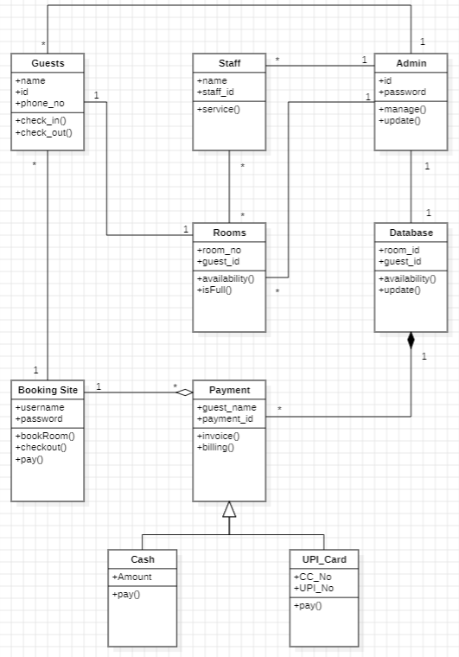

1. **CREDIT CARD PROCESSING SYSTEM:**

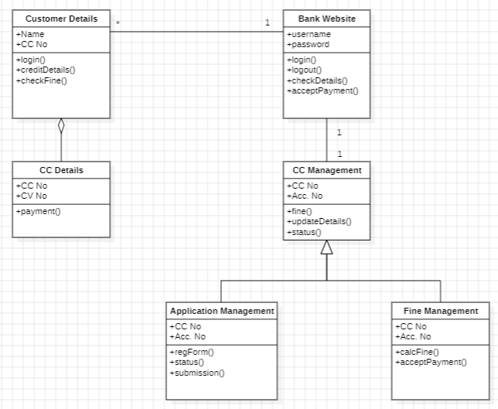

1. **LIBRARY MANAGEMENT SYSTEM:**

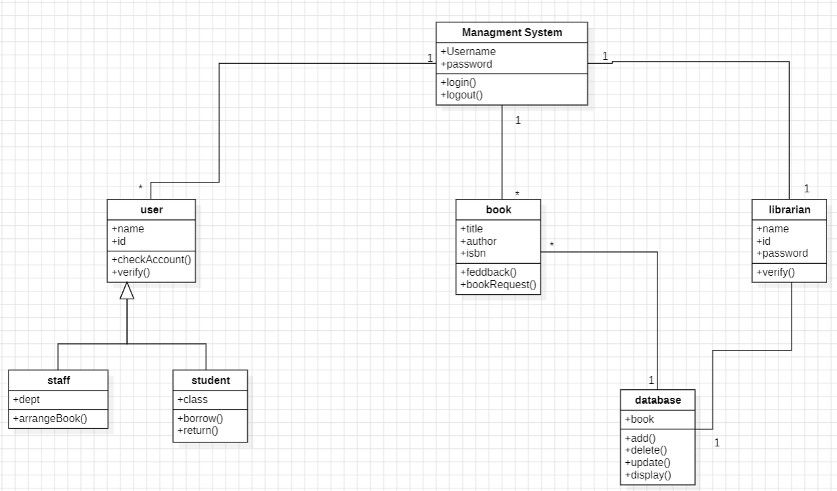

1. **STOCK MAINTENANCE SYSTEM:**

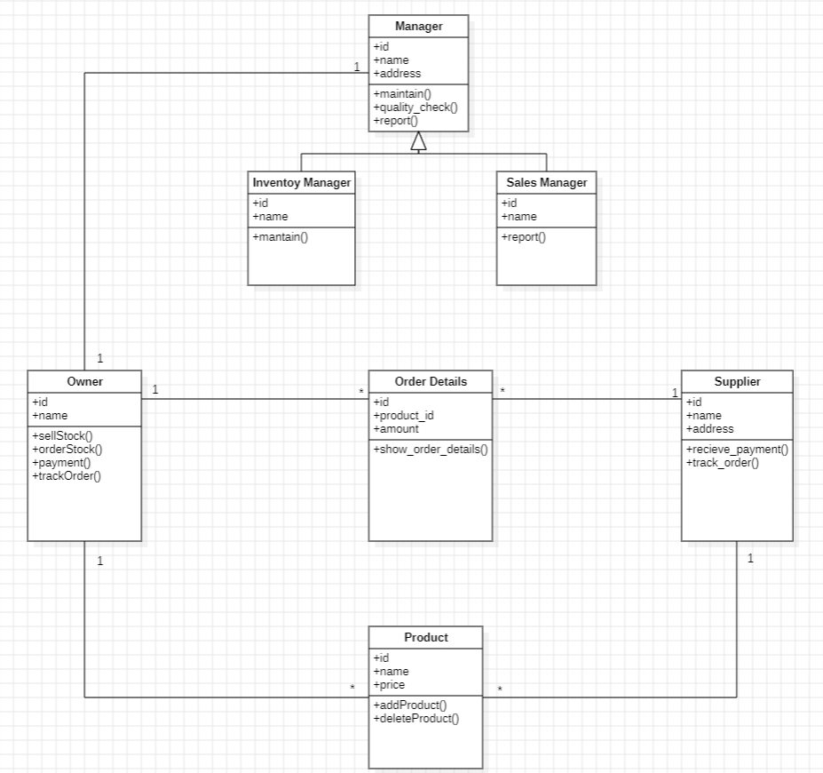

1. **PASSPORT AUTOMATION SYSTEM:**

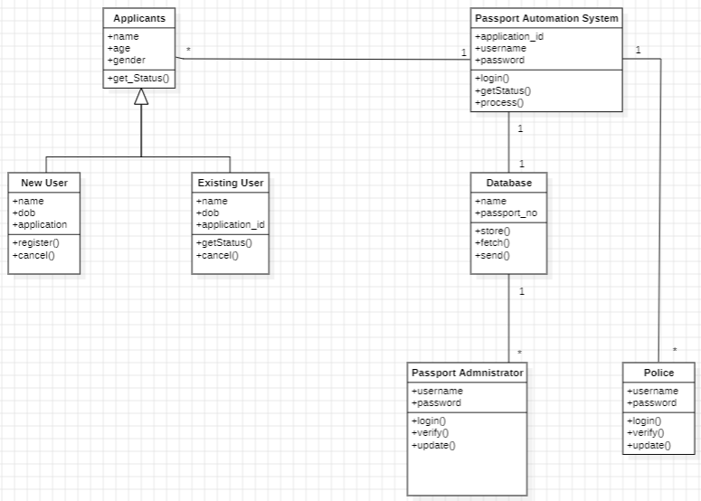

**STATE MODELING**

1. **HOTEL MANAGEMENT SYSTEM:**

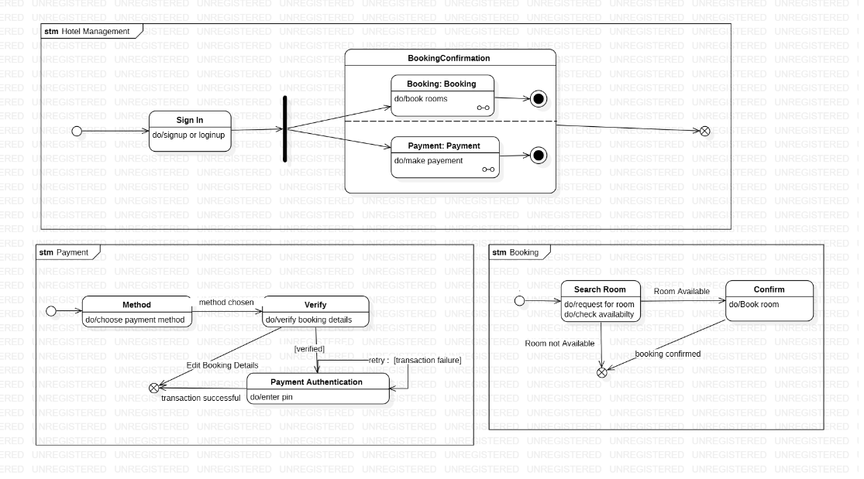

**2)CREDIT CARD PROCESSING SYSTEM:**

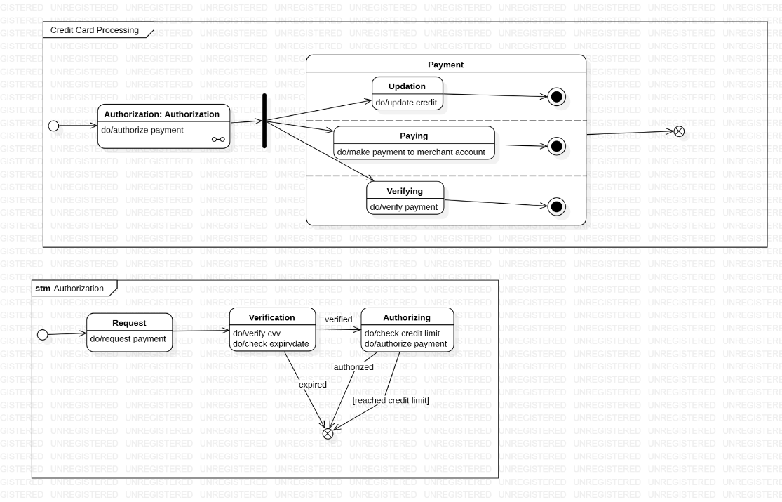

**3)LIBRARY MANAGEMENT SYSTEM:**

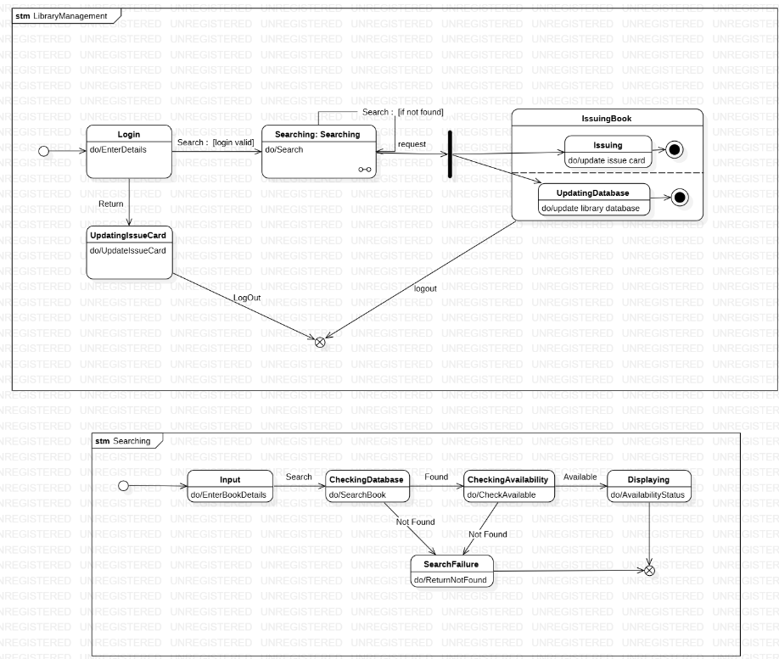

**4)STOCK MAINTENANCE SYSTEM:**

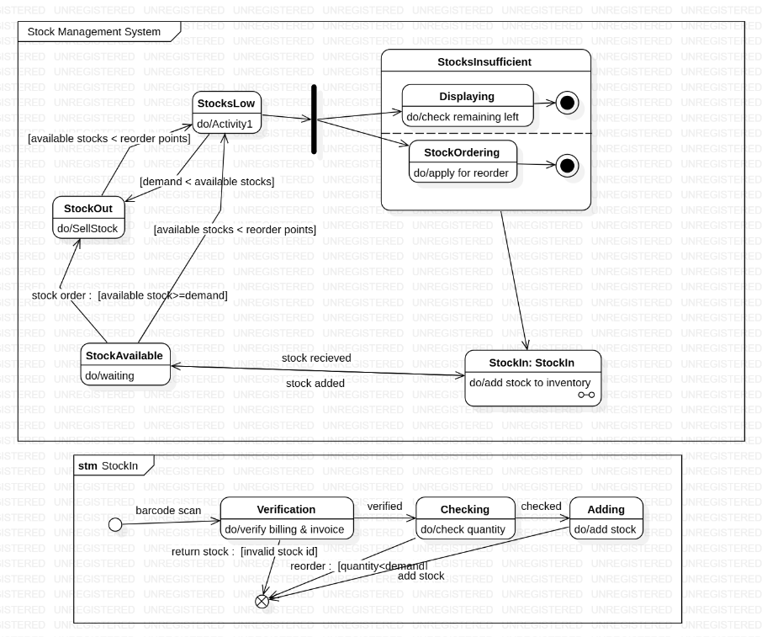

**5)PASSPORT AUTOMATION SYSTEM:**

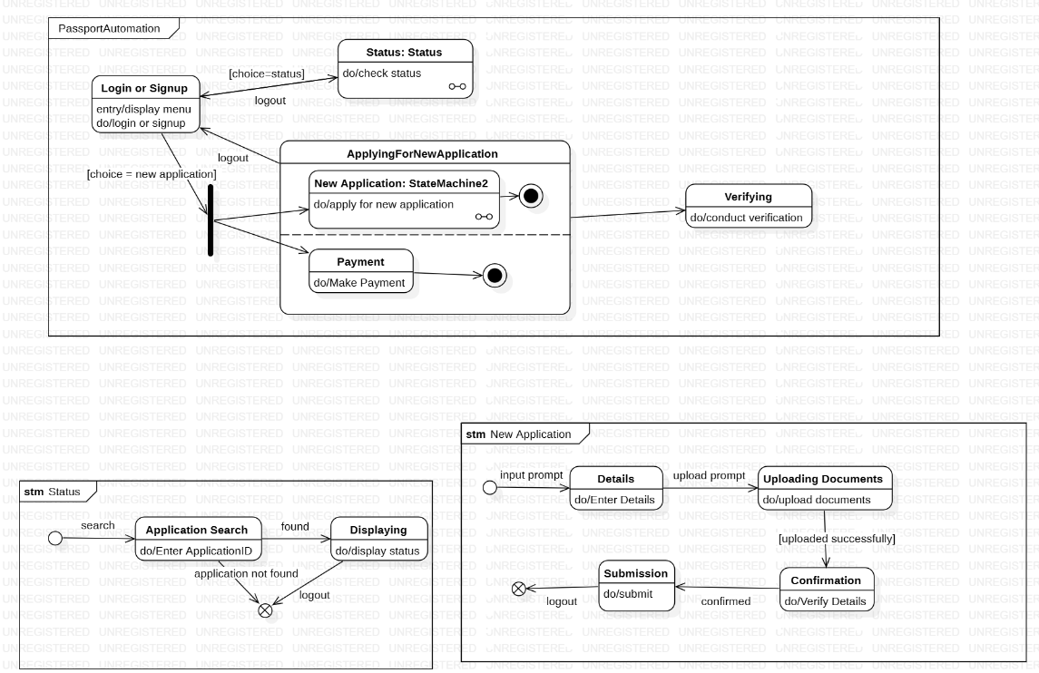

**USE CASE MODELS**

1. **HOTEL MANAGEMENT SYSTEM:**

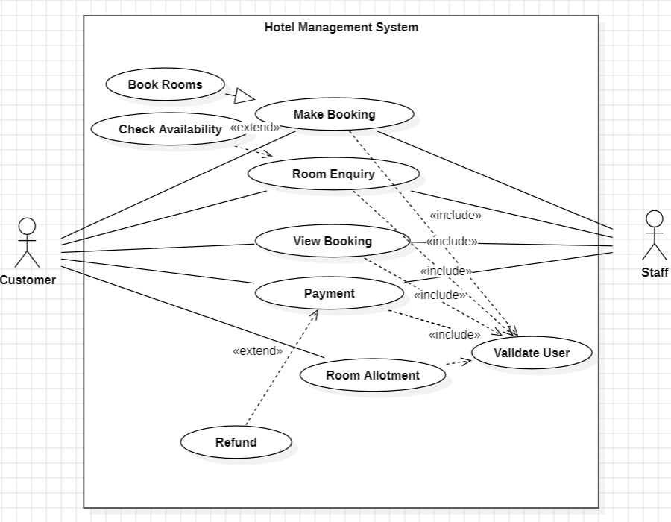

1. **CREDIT CARD PROCESSING SYSTEM:**

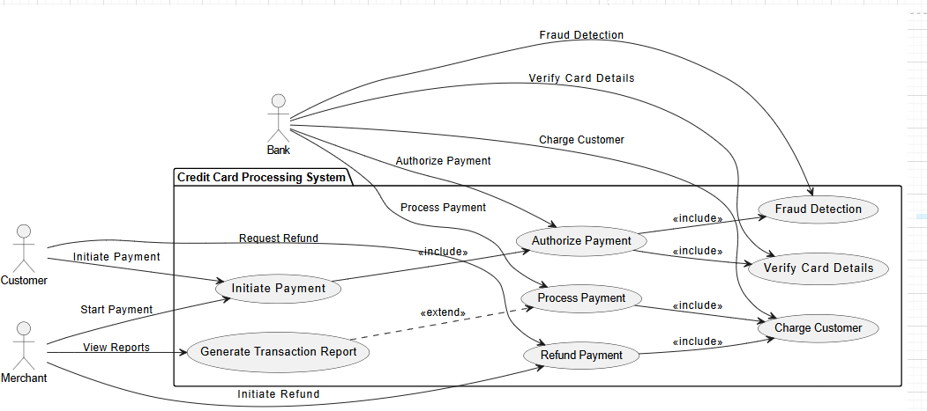

1. **LIBRARY MANAGEMENT SYSTEM:**

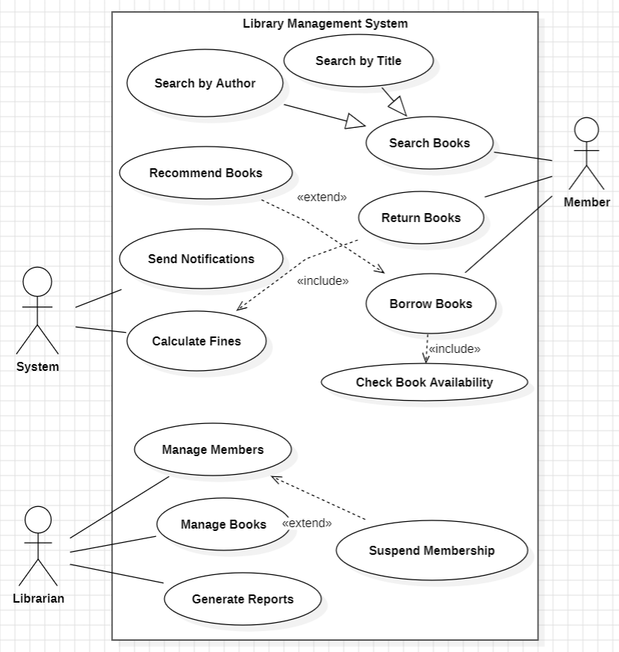

1. **STOCK MAINTENANCE SYSTEM:**

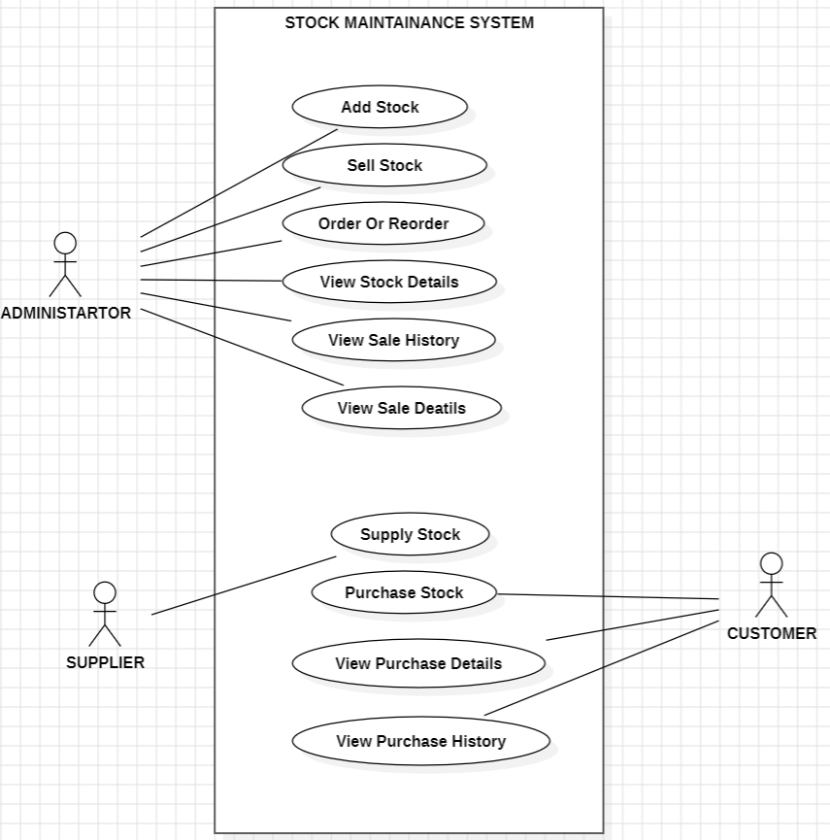

1. **PASSPORT AUTOMATION SYSTEM:**

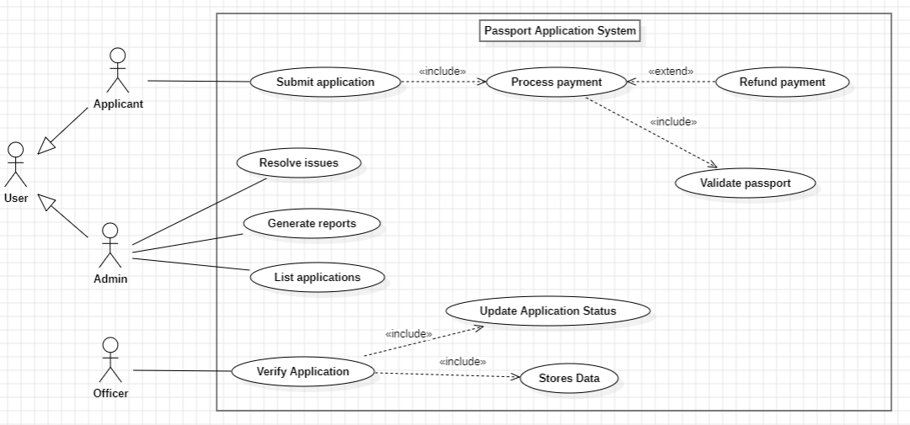

**SEQUENCE MODELS**

1. **HOTEL MANAGEMENT SYSTEM:**

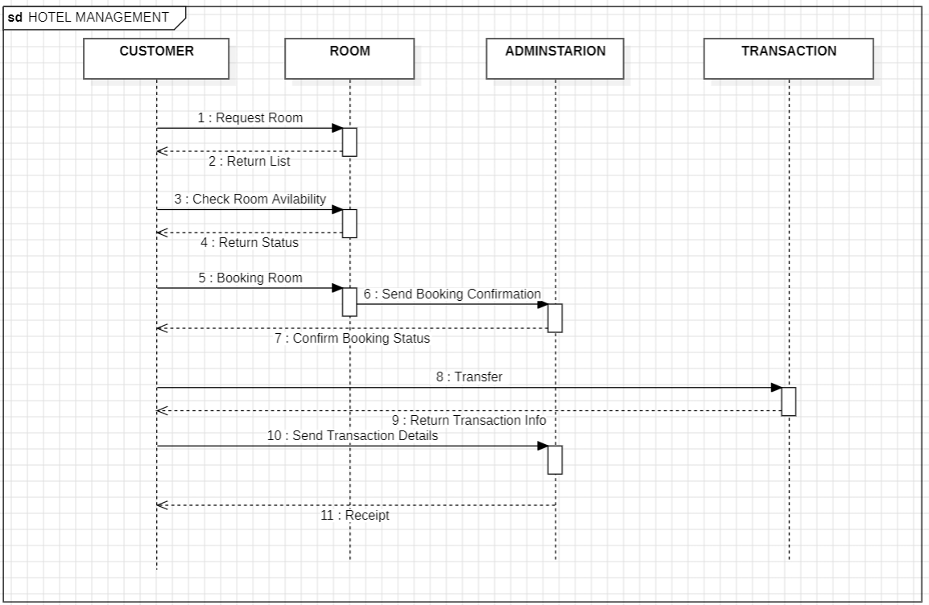

1. **CREDIT CARD PROCESSING SYSTEM:**

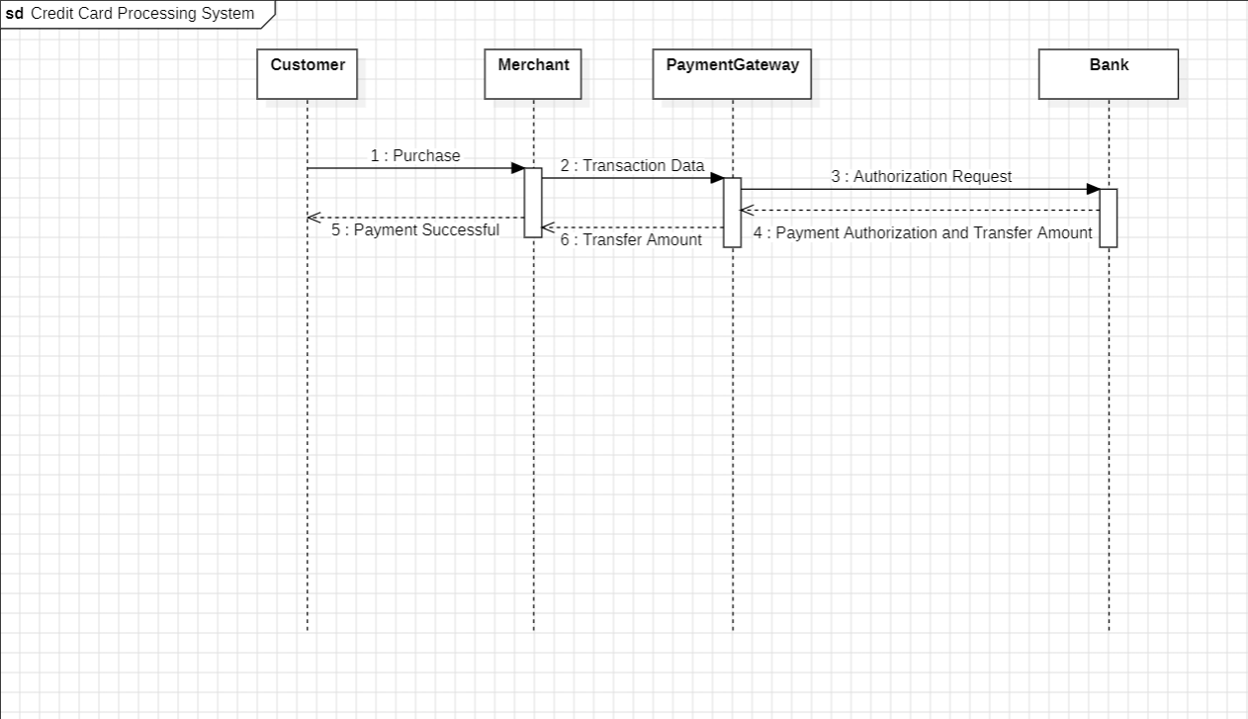

1. **LIBRARY MANAGEMENT SYSTEM:**

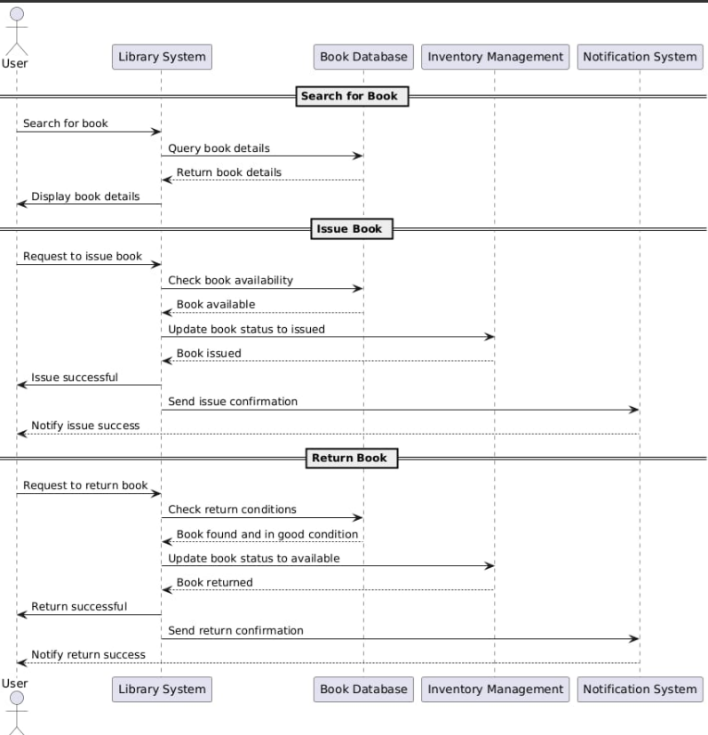

1. **STOCK MAINTENANCE SYSTEM:**

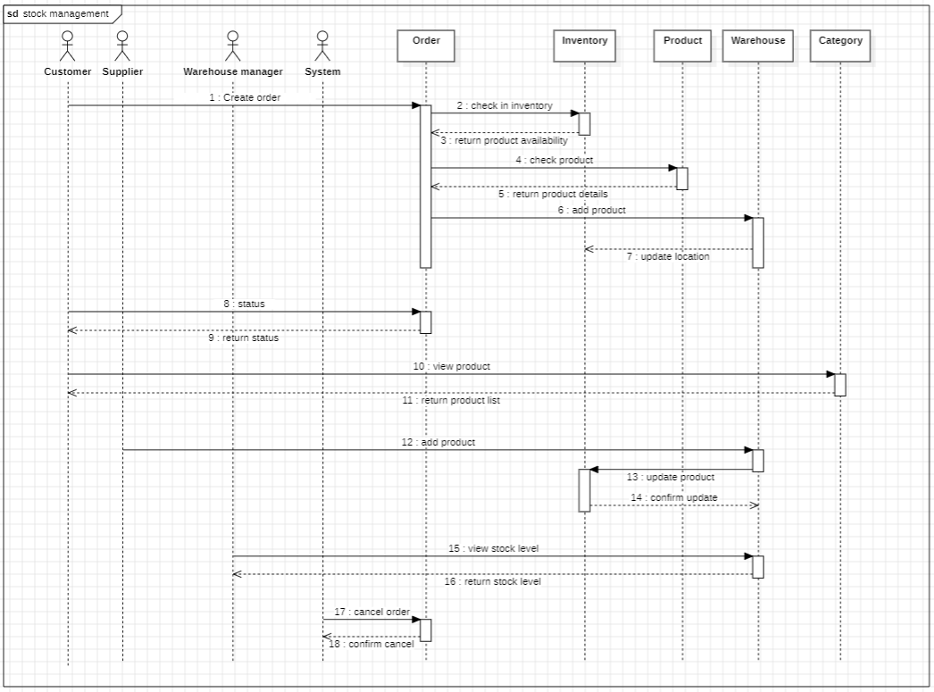

1. **PASSPORT AUTOMATION SYSTEM:**

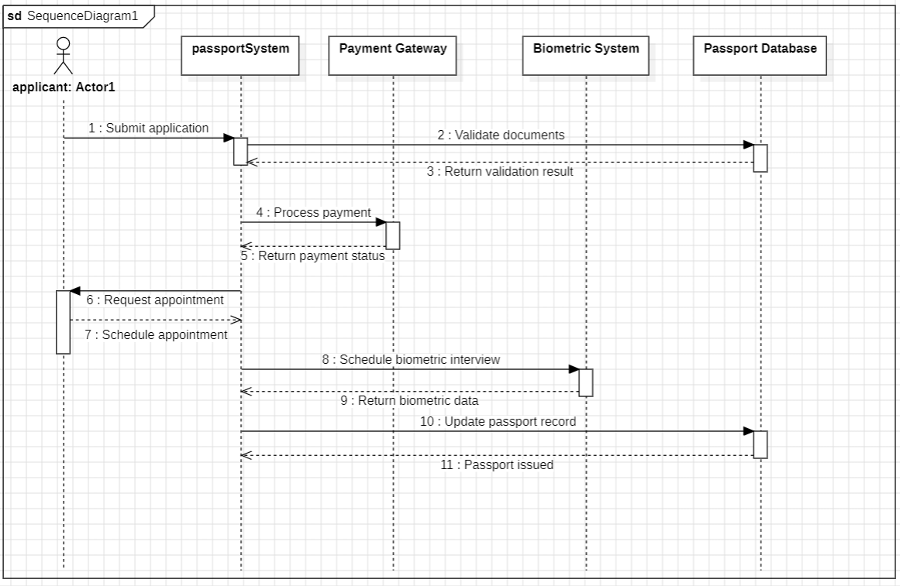

**ACTIVITY MODELS**

1. **HOTEL MANAGEMENT SYSTEM:**

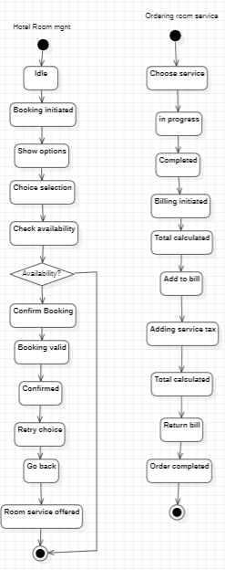

1. **CREDIT CARD PROCESSING SYSTEM:**

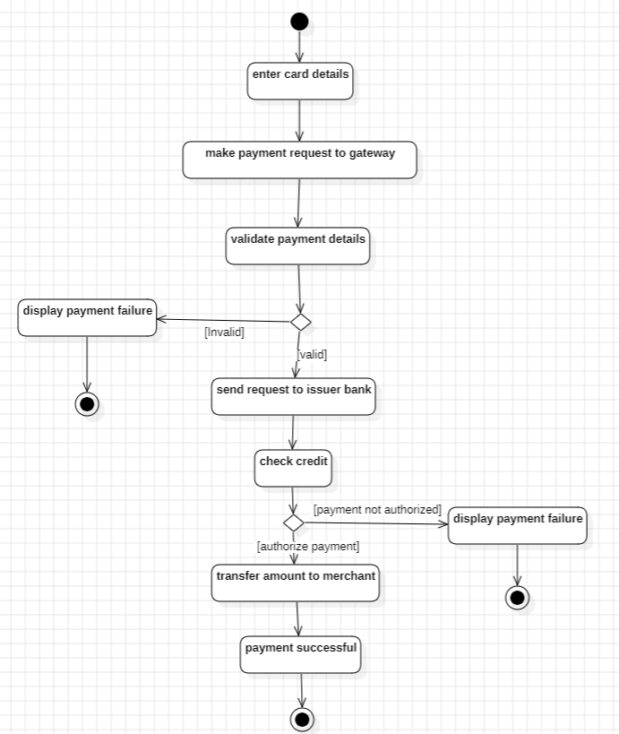

1. **LIBRARY MANAGEMENT SYSTEM:**

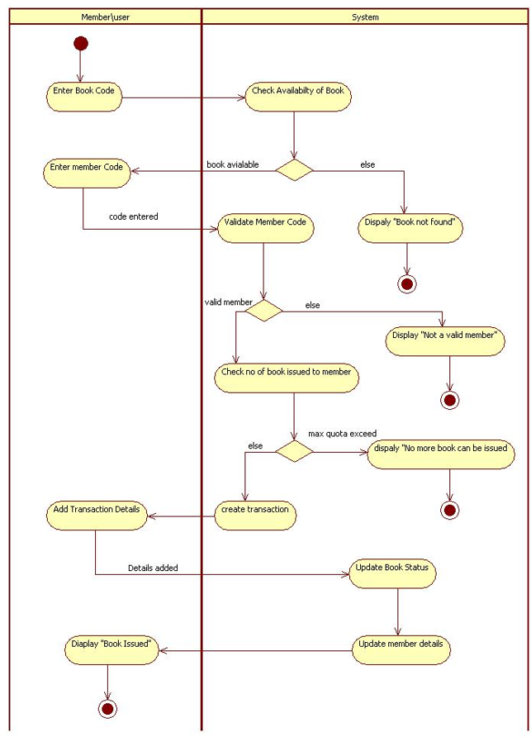

1. **STOCK MAINTENANCE SYSTEM:**

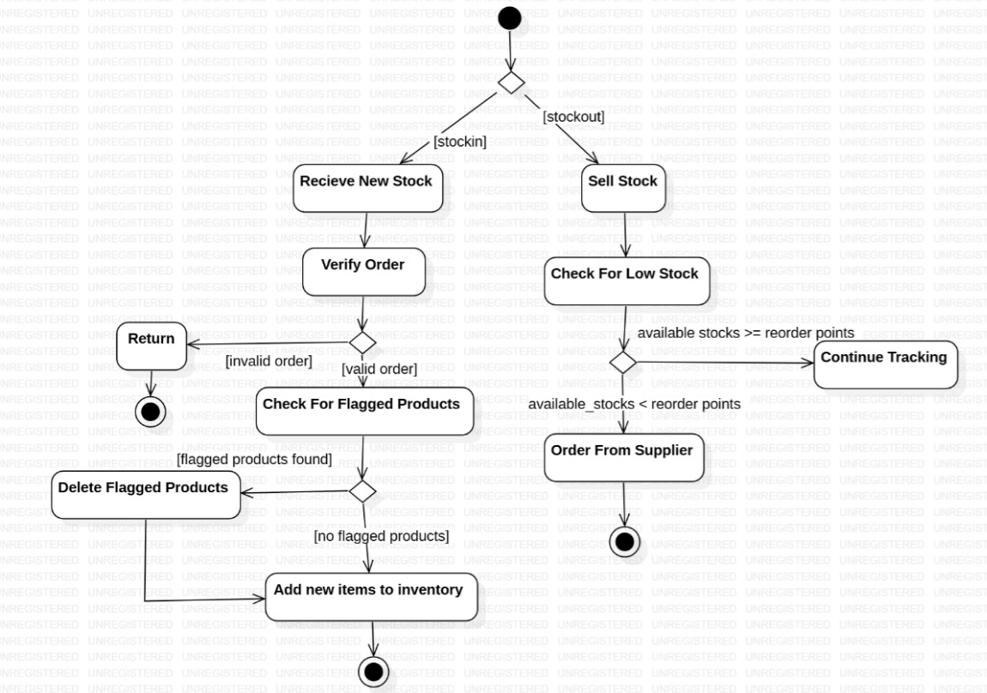

1. **PASSPORT AUTOMATION SYSTEM:**

